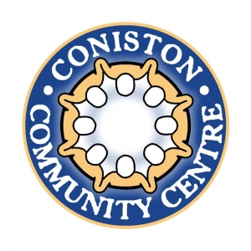

**Coniston Connect**

**Sign-up form**

Coniston Connect is particularly aimed at those over 55 in our community who find it difficult to leave their home and would like to have door to door transport in a community transport accessible minibus to enjoy a day at Coniston Community Centre every week.

We’re really looking forward to meeting you! We just need to know a little bit about you – and what you might like to take part in, first.

Please complete this form and return it to Coniston Community Centre, The Parade, Coniston Road, Patchway, BS34 5LP. An electronic copy of this form can be found on our website at conistoncommunitycentre.org.uk or ring us on 0117 923 6878 or 07984 161229 and we’ll complete the form on your behalf.

**Name:**

**Address:**

**Contact details** (this can be your phone number or email address - or that of a person you’d prefer us to contact on your behalf):

**Emergency contact details** (please give a name and phone number of a relative, friend or neighbour we can contact in an emergency):

**Activities you’d like to take part in:**

Tuesday mornings from 4th June – 29th August 2024

**Mini bus collection from your home** (around 10.00am) **and return journey** (around 2.00pm). An additional sign-up form is needed so if you want to use this service, we’ll pop the form round. **Cost £3**

**Crafty Corner** (bring your own projects – knitting, crochet, embroidery, card making, art – whatever you’re currently working on). 10.00am – 12.00 noon. **Cost £FREE**

**Art and craft facilitated session** - all materials provided. Come and learn some new skills or develop your current ones! 10.00am – 12 noon. Cost **£FREE**

**Games and puzzles corner** – come along, have some fun and make new friends. 10.00am – 12.00 noon. **Cost £FREE**

**Armchair Exercise facilitated session** – 45 minute session led by a professional teacher of Tai Chi. Find out how gentle movements to music can improve your body and mind. Between 10.00am – 12.00 noon. **Cost £FREE**

**Lunch** – enjoy a freshly cooked nutritious two course meal cooked by our fabulous café team and a cup of tea, whilst chatting to your new friends (and making others). 12.00 noon – 2.00pm. **Cost £3**

**Do you have any dietary needs e.g. vegetarian/vegan, gluten free/sugar free etc?**

**Terms and conditions:**

Just so you know, this project runs for 13 weeks and is subsidised thanks to a grant from St Monica Trust and donation in kind from Coniston Community Association. Once your 13-week period is complete, we’d love you to continue coming along to spend time with us and all your new friends - and we will help make this work for you.

Coniston Community Centre is fully accessible, so we can accommodate your needs. If you need the support of a carer, they are welcome to come along and take part in all activities for free, with just a small charge for lunch.

Other activities may be added during your 6-week period and you would be most welcome to join in with these. We also plan to include other days of the week as this project develops.

We really look forward to getting to know you!

*The Coniston Connect Team*