Name
Company name
Address
Postcode
Telephone number
Email

Date/s required
Activity
Room(s) required  (Please circle) | 1 | 2 | 3 |  | 4 |  | Café |  | Café & kitchen |  |  | The Wellbeing Centre
Frequency | One-off |  |  |  |  | Weekly |  |  |  | Monthly
Time required | : - :
Room layout  (see overleaf) | Boardroom |  |  | Cabaret |  |  | Classroom |  | U -Shape |  |  |  | Theatre
Optional Extras | Flipchart Stand |  | Hot Water Urn |  |  |  |  | Catering |  |  | Refreshments
Please give any information of room set up requirements:

Purchase Order Number or Reference Number:

Terms and Conditions
I wish to hire the room/s as stated, and will abide to the condition of hire which are:
- Party/Event bookings must be paid for in advance (minimum 14 days)
- Other bookings must be paid within 14 days of invoice
- If the booking needs to be cancelled, more than 48 hours’ notice must be given otherwise the hirer will be charged the full amount.
- To treat the building and its contents with respect and ensure no damage is incurred.
- The hirer is liable for all damages and all accidents and must be reported immediately to the Centre Manager.
- The rooms must be left in same condition as they were found, with all rubbish and decorations removed. Failure to do so may incur loss of deposit.
- The safety regulations of the building must be adhered to, for example, the front door must not be propped open.
- The hirer is not to disturb other rooms or other hirers and access is only available for the rooms booked.

I agree and sign here…………………………………………………………………... Date …………………………………

Please complete and return this form to:
The Centre Manager, Coniston Community Centre, The Parade, Patchway, Bristol, South Gloucestershire, BS34 5LP
Telephone: 0117 9236878 or E-mail: info@conistoncommunitycentre.org.uk
GDPR Compliant
We only take the above information to contact you directly about your room booking, update you on Coniston matters and to send the invoice for hire. All information is stored securely with our DPO (Date Protection Officer) and when no longer required destroyed.

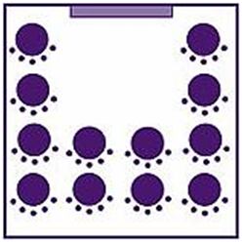
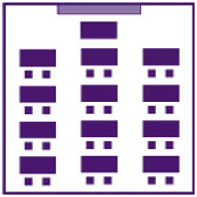
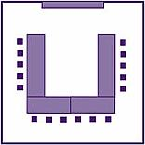
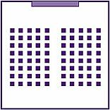
Layout
Theatre Style:
Rooms 3 and 4 can hold a maximum of 60 people in this style.
Rooms 3 and 4 (together) can hold a maximum of 120 people.
Rooms 1 and 2 (together) can hold a maximum of 60 people in this style.
U Shape:
Rooms 3 and 4 can hold a maximum of 24 people in this style.
Rooms 1 and 2 can hold a maximum of 12 people.

Classroom Style:
Rooms 3 and 4 can hold a maximum of 36 people in this style.
Rooms 1 and 2 can hold a maximum of 12 people.
Boardroom Style:
Rooms 3 and 4 can hold a maximum of 20 people in this style.
Rooms 1 and 2 can hold a maximum of 15 people.
Cabaret Style:
Rooms 3 and 4 can hold up to 40 people in this style.
Rooms 1 and 2 can hold up to 25.

