Name
Company name
Address
Postcode
Telephone number
Email

Date of booking |  |  |  | Date(s) of hire
Times required
Activity Description
Anticipated numbers
Room(s) required | 1 | 2 |  |  | 3 |  | 4 |  |  | Café Only |  |  | Advice Room
 | 1 and 2 together |  |  |  | 3 and 4 together |  |  |  |  | Café + Kitchen
Frequency | One-off |  |  |  | Weekly |  |  |  |  | Monthly
Room layout (see attached guide) | Boardroom |  | Cabaret |  |  | Classroom |  | U -Shape |  |  |  | Theatre
Optional Extras (additional charges will apply) | Projector and Screen |  | Flipchart Stand |  |  | Hot Water Urn |  | Cupboard Storage |  |  | Event Promotion
Will Catering/Refreshments be required? (These should be ordered separately via Brooks Café on 07969627104) | YES/NO
Please give any additional information with regards to room requirements.

Purchase Order or Reference Number (if applicable):

I agree to the Terms and Conditions as set out below.

Signed ……………………………………………………………………………...

Print Name:

Terms and Conditions
I wish to hire the room(s) as stated, and agree to the conditions of hire which are:

- To pay the hire charge within 14 days of invoice.
- To provide as much notice as possible should the booking need to be cancelled. Failure to provide notice of a cancellation, either verbally or in writing, will incur the full hire charge.
- To leave the room in the same condition in which it was found e.g. all rubbish to be cleared away, tables to be wiped clean, crockery and cutlery to be washed and kitchens left clean and tidy. Failure to do so will incur a cleaning charge.
- To adhere to all appropriate fire safety measures by switching off and unplugging electrical appliances, not wedging open any identified fire doors or blocking any fire exits.
- To ensure the security of the building and its users by adhering to appropriate security measures.
- To be mindful of other users to the centre and to report any inappropriate behaviour to the Centre Manager.

The Hirer is liable for all damages which must be reported immediately to the Centre Manager. The Centre will not tolerate violent or abusive behaviour to any of its staff and volunteers. In order to obtain access to the building outside of office hours, the hirer will be required to obtain an electronic key for which a refundable deposit will be required.

The Coniston Community Centre agrees to provide a clean and safe environment in accordance with appropriate health and safety regulations and to the hirer’s requirements.

The Coniston Community Centre is operated and regulated by the Coniston Community Association .
Registered Charity Number 1036917.

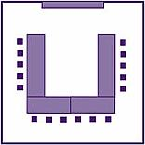Room Layout Options
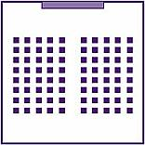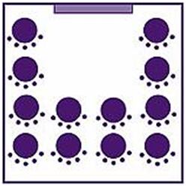
Theatre Style:
Rooms 3 and 4 can hold a maximum of 60 people in this style.
Rooms 3 and 4 (together) can hold a maximum of 120 people.
Rooms 1 and 2 (together) can hold a maximum of 60 people in this style.
U Shape:
Rooms 3 and 4 can hold a maximum of 24 people in this style
Rooms 1 and 2 can hold a maximum of 12 people.

Classroom Style:
Rooms 3 and 4 can hold a maximum of 36 people in this style
Rooms 1 and 2 can hold a maximum of 12 people.
Cabaret Style:
Rooms 3 and 4 can hold up to 40 people in this style.
Rooms 1 and 2 can hold up to 25.
Boardroom Style:
Rooms 3 and 4 can hold a maximum of 20 people in this style
Rooms 1 and 2 can hold a maximum of 15 people.

